

Soliton Technologies Pvt. Ltd.

Software Design Document
Version 1.0

EATON POWER STEERING AIR LEAK TEST SYSTEM
ALTS

© Soliton Technologies Pvt. Ltd.

Table of Contents

1 Revision History 4
2 Introduction 5
2.1 Purpose 5
2.2 Definitions, Acronyms, Abbreviations 5
3 System Configuration 5
3.1 Software Configuration 5
3.2 Hardware Configuration 5
4 Channel List 5
5 Software Architecture 7
5.1 Architecture Overview 7
6 Modules Design 7
6.1 Authentication Module 7
6.2 Auto Mode Module 10
6.3 Leak Test Instrument Communication Module 12
6.4 Database Communication Module 12
6.5 Serial Details Communication Module 13
6.6 DAQ Engine Module 13
6.7 INI File Management Module 14
7 Error Handling 14

List of Tables

Table 1: Design Validation Table 7

List of Figures

Figure 1: Overall Architecture 8
Figure 2: Authentication Screen 9
Figure 3: Add User Information Screen 9
Figure 4: Edit User Information Screen 10
Figure 5: Delete User Information Screen 10
Figure 6: Auto Mode Main Screen 13

Revision History

Ver # | Date | Created by | Reviewed by | Approved by | Revision Details
1 | 04-May-2015 | Ajayvignesh |  |  | Initial release

Introduction

Purpose
The Purpose of this Design Document is to give an overall design and view of software development of each module will be implemented.

Definitions, Acronyms, Abbreviations
TC-Test Complete
DB- Database
SN- Serial Number

System Configuration

Software Configuration
- NI LabVIEW 2013
- NI DAQmx 8.9.5 or later
- NI Database communication Toolkit

Hardware Configuration
- NI PCI - 6514 - Part Number 778836-01

Channel List
ALTS-2015 uses NI PCI 6514(32 Digital Inputs / 32 Digital Outputs). The configuration of this card is as follows

Digital Inputs:

- STATION1_START
- STATION1_STOP
- STATION1_CLAMPED
- STATION1_TC_PASS
- STATION1_TC_FAIL
- STATION1_TTA
- STATION1_TTB
- Not Used
- STATION2_START
- STATION2_STOP
- STATION2_CLAMPED
- STATION2_TC_PASS
- STATION2_TC_FAIL
- STATION2_TTA
- STATION2_TTB
- Not Used
- STATION3_START
- STATION3_STOP
- STATION3_CLAMPED
- STATION3_TC_PASS
- STATION3_TC_FAIL
- STATION3_TTA
- STATION3_TTB
- Not Used
- STATION4_START
- STATION4_STOP
- STATION4_CLAMPED
- STATION4_TC_PASS
- STATION4_TC_FAIL
- STATION4_TTA
- STATION4_TTB
- Not Used

Digital Outputs:

- STATION1_START TEST
- STATION1_STOP TEST
- STATION1_INDICATOR_1
- STATION1_INDICATOR_2
- STATION1_INDICATOR_3
- Not Used
- STATION1_SELECT_TEST
- Not Used
- STATION2_START TEST
- STATION2_STOP TEST
- STATION2_INDICATOR_1
- STATION2_INDICATOR_2
- STATION2_INDICATOR_3
- Not Used
- STATION2_SELECT_TEST
- Not Used
- STATION3_START TEST
- STATION3_STOP TEST
- STATION3_INDICATOR_1
- STATION3_INDICATOR_2
- STATION3_INDICATOR_3
- Not Used
- STATION3_SELECT_TEST
- Not Used
- STATION4_START TEST
- STATION4_STOP TEST
- STATION4_INDICATOR_1
- STATION4_INDICATOR_2
- STATION4_INDICATOR_3
- Not Used
- STATION4_SELECT_TEST
- Not Used

Software Architecture

Architecture Overview
The following figure shows the various Modules used and communication between each Module.

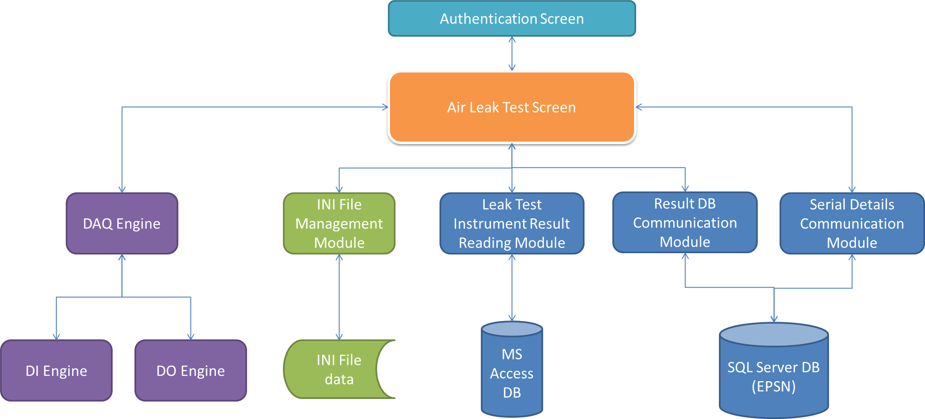

Figure 1: OVERALL ARCHITECTURE

Modules Design

Authentication Module

Once the software is launched, this Module will be executed first. The User Accounts information are stored in a encrypted file. The User has to Login the User Name and Password and it must be valid in order to continue with the testing. The below screen shows the Authentication Main Screen.
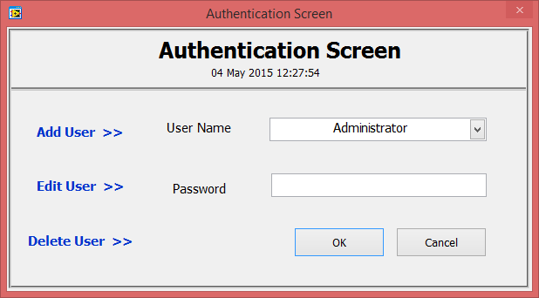
Figure 2: Authentication Screen

Once the OK Button is pressed, the same user will be used for all four stations. Only Administrator will be allowed to create and edit login details. Also the User will be able to select Add User, Edit User, and Delete User Options only when the User Login is correct.
The below screen is displayed when the user selects Add User from the Authentication Screen.

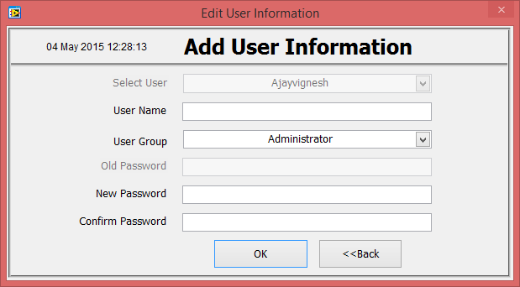
Figure 3: Add User Information Screen

The below screen is displayed when the user selects Edit User from the Authentication Screen.

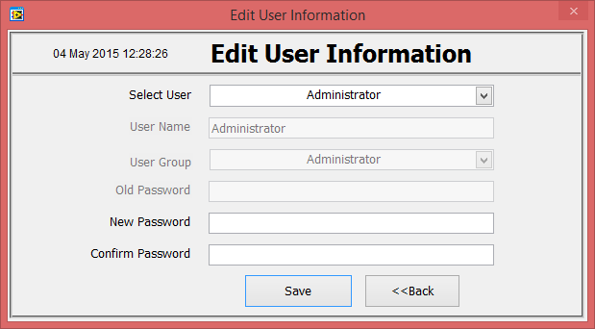
Figure 4: Edit User Information Screen

The below screen is displayed when the user selects Delete User from the Authentication Screen.

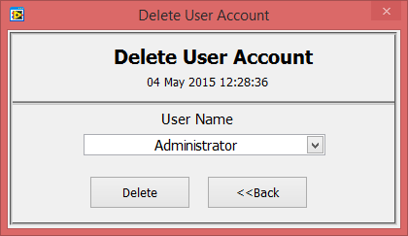
Figure 5: Delete User Information Screen

Auto Mode Module
The run module will have User Interface to display all 4 stations status with work order and Serial Number in progress. Following steps will explain the operation in sequence and proposed functionality of this module.

- After successful authentication, the User Name will be displayed in the Auto mode screen
- From the INI File Management Module, software decides the Number of Test Stations to Run and disable the Remaining Test Station. Also the Sensor IDs for Each Station is read from the INI file and displayed in the respective station indicators on the Front Panel.
- All the station details will be empty at this time and software will lid status indicator light to indicate station is Idle and ready to scan new serial number and then loading.
- Software will have User Interface displaying all 4 stations status. Each station will have following information.
  - Work Order Number
  - Sensor ID
  - Serial number
  - Test Data Results.
- Serial Number
- Pressure
- Flow
- Test Time
- Test Status
  - Robot Action
  - Station Status

- The software has Exit button which is button will close the ALTS-2015 Application.

- The work order number will be updated from INI.
- The Auto Mode Module will check for the DI and DO Global status all the time as they are updated from the DAQ module running parallel.
- When the UUT comes in through the conveyor, Robot will send the scan trigger to the software through OPC tag ([AIR_LEAK]Scan_Trigger). Then the serial number will be scanned from either of the scanner two scanners. Followed by, software will get the valid serial from either one of the scanner. Basic Serial Number format check will be done. If the Serial Number is passes basic check, it will be cross-checked with its entry in the DB. Only if the both of this check are passed, the serial number is considered as valid serial.
- On receiving the invalid serial number, software will command the robot about invalidity of the serial number. Robot will then put the invalid serial into the “Invalid Bin”. Ref. flowchart AutoALTS-PLC Program Flow.pdf for more details on this logic.
- On receiving the valid serial number, software will fetch the various detail of the new serial number from the DB. Software will then send these details about the new serial to the robot. Software will also send the station number to which the new serial to be loaded. Based on these inputs, robot will fetch the UUT, clamp it in said station then send the start signal to software over OPC ([AIR_LEAK]Start_Test).
- When the Unit is clamped successfully, the station status will change to indicate Unit Clamped.
- Serial number and will be displayed in the Test Station in which the unit is clamped.
- Upon sensing the start tag, software will check whether the clamping pressure switch is high. If it is high the software will change the test type in the station by sending the digital pulses through “Select Test”. The test type to be selected would be extracted from the serial details. Test type selection is then verified with the feedback signal (STATIONX_TTA & STATIONX_TTB) from the ALT instrument. Upon conforming the feedback signal, software will start the test by outputting a DO signal (STATIONX_START TEST) to Leak Test Measurement Instrument to start the test.
- While the Test is Running, the Status Indicator will change to indicate the test is running
- If the Clamping Pressure is not high, the software will not start the test.
- Upon completion of test, the instrument will output a digital output (STATIONX_TC_PASS and STATIONX_TC_FAIL) to DIO card. Upon sensing test completion, the Leak Test Instrument Communication Module will send the Test Data Results to MS Access Database table. (See it in detail in the Leak Test Instrument Communication Module). At this time the status indicator light will change state to indicate that test is completed (Pass / Fail) in this particular station.
- If the test fails, software will command the robot to rerun the test if rerun is configured in INI file.
- If the test fails for the maximum rerun count in INI, then the UUT is considered as failed. Then software will send the failure command to the robot to handle it accordingly. Ref. flowchart for more details. Robot is expected to put the UUT in to fail conveyor in this case.
- If the test passes, then software will command the robot to handle it accordingly. Robot is expected to put the UUT in to pass conveyor in this case.
- Also the test results for each station will be read from MS Access DB and written to the SQL Server Database through the Stored Procedure Call (See it in detail in the Database communication Module).
- Once the UUT is unloaded the status indicator light will change to (IDLE) indicate the station is available for next UUT.
- Robot (or operator) can stop the test at any time by sending the OPC tag [AIR_LEAK]Stop_Test. Software in turn communicates this to Leak Test Instrument through DO (STATIONX_STOP_TEST). This will abort the test.
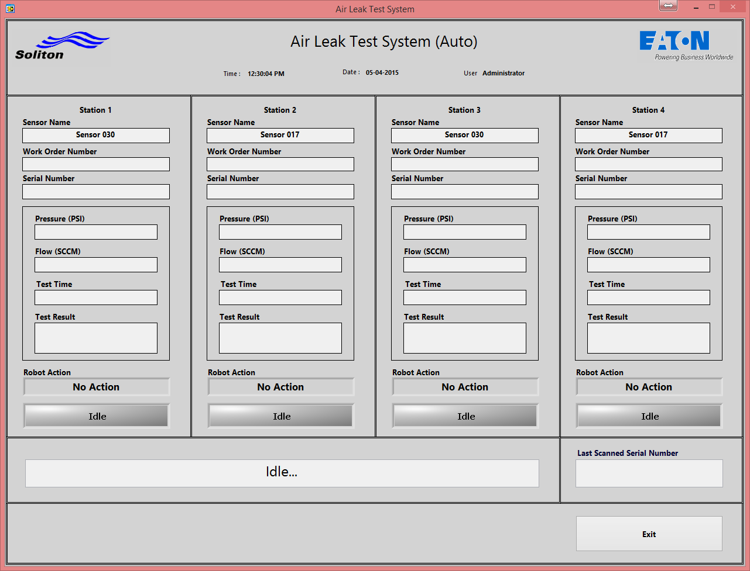
Figure 6: Auto Mode Main Screen

Leak Test Instrument Communication Module
Initialize – Will open connection to MS Access database table and store it in shift register. Table file path is read from INI file. Also the sensor name of all 4 stations will be read from INI and kept in shift register.
Read Result - After completing the test, Leak Test Instrument will write the test results to a MS Access Database table. This module will query the Test Result table for recent test data under particular sensor name. The Parameters that are read from the table are Pressure, Flow, Test Status (Pass/Fail) and Test Time.
- Input – Station ID enum
- Output – Test Results Cluster

Close – Will close the DB connection and release the memory.

Database Communication Module
Initialize – Will open connection to SQL Server DB. All required parameter to open the connection will be kept in the INI file.
- DSN File path.
- Stored procedure call
- Also the sensor name of all 4 stations will be read from INI and kept in shift register
Write Result - This module will write the test result to SQL DB through a stored procedure call. All the inputs needed will be read from respective LV2GBLs.
- Input – Station ID enum
- Output – None.
- Stored Procedure call format= {sp_AIR_LEAK_RESULTS(?,?,?,?,?,?,?,?,?,?,?)}
- Actual format = {sp_AIR_LEAK_RESULTS(Sensor_name,SN,Work_Order_Number,User1,User2,User3,User4, Pressure,Flow,Test_Result,Test_Time)}
  - Sensor_Name – String, 50 char
  - SN- String, 13 char
  - Work_order_Number- String, 50 char
  - User1 – String, 50 char
  - User2 – String, 50 char
  - User3 – String, 50 char
  - User4 – String, 50 char
  - Pressure – Double
  - Flow – Double
  - Test_Result – String, 4 Char (Pass, Fail)
  - Test_Time – String, 14 Char (Format = YYYYMMDDHHMMSS)

Close – Will close the DB connection and release the memory.

Serial Details Communication Module
Initialize – Will open connection to SQL Server DB. All required parameter to open the connection will be kept in the INI file.
- DSN File path.
- Stored procedure call
- Also the sensor name of all 4 stations will be read from INI and kept in shift register
Read - This module will read the serial details form SQL DB through a stored procedure call.
- Input – Serial Number
- Output – Adapter Plate Size, Air Leak Test Type, Displacement Size, Flange Size, Height, Load Decision, Cart Insert.
- Stored Procedure call format= {call sp_ALL_GET_AirLeakLookup_from_SN(?)}
- Actual format = {call sp_ALL_GET_AirLeakLookup_from_SN(Serial Number)}
  - SN- String, 13 char

Close – Will close the DB connection and release the memory.

DAQ Engine Module
We have two sub modules – DI (Digital Input) and DO (Digital Output).

Digital Inputs:

    - If the Unit is clamped properly, it is indicated to the Software through Clamping Pressure Switch (STATIONX_CLAMPED).
    - After completing the test, Leak test instrument will send the Pass/Fail Status to Digital Input (STATIONX_TC PASS), ((STATIONX_TC FAIL).
    - After the Test Select pulses are sent to change the test type, the confirmation is done through the Digital Inputs viz. STATIONX_TTA, STATIONX_TTB

Digital Outputs:

    - If the Start tag is received and Unit is clamped properly, then Software will send a Digital Output (STATIONX_START TEST) to the Leak Test Instrument to indicate starting of the Test.
    - If the Stop Buttion is pressed and the test is running, the software will send a Digital Output (STATIONX_STOP TEST) to the Leak Test Instrument to stop the test.
    - The overall test Running status is updated to the light Indicator in each Station through digital outputs (STATIONX_INDICATOR_IDLE, STATIONX_INDICATOR_TEST RUNNING,
STATIONX_INDICATOR_PASS, STATIONX_INDICATOR_FAIL)
    - After receiving the START tag from robot, the test type selection in the ALT instrument is changed trough Digital Output Select Test (STATIONX_Select Test) pulses.

The DI and DO lines are continuously Monitored and status is Stored in the DI LV2global and DO LV2global respectively by this DAQ engine module.

INI File Management Module

In this Module, the INI file Parameters are read and stored in the LV2Global to use in various Places in Software

- Number of Test Stations to Run
- Sensor Name 1
- Sensor Name 2
- Sensor Name 3
- Sensor Name 4
- DB Stored Procedure
- MS Access DB Table File Path
- OPC Tags (Read & Write)
- Rerun Count
- Workorder Number
- Barcode Scanner1
- Barcode Scanner 2
- Simulation details.

Error Handling
Errors will be captured and transferred to a shift register of the main loop state machine. A case called ‘Error’ will process and handle the error, prompting the error to the User by means of dialog message.

